
SCHOOL OF COMPUTING AND ENGINEERING SCIENCES (SCES)
BACHELOR OF SCIENCE IN ELECTRICAL AND ELECTRONICS ENGINEERING (BSEEE)
DIGITAL ELECTRONICS LAB THREE.
MINIMIZATION OF LOGIC EXPRESSIONS AND IMPLEMENTATION OF LOGIC EXPRESSIONS
GROUP 16
BY:
- Mwongela Edward Aribu 142092
COLLABORATORS:
- Nzioki, Andrew Christopher | 145168
- Karumbi, Ivy Waceke | 145338
- Onyango, Andrian Achieng | 146738

Table of Contents
LIST OF FIGURES 3
INTRODUCTION 4
METHODOLOGY 5
Objectives: 5
Learning Outcome 5
Equipment Needed 5
Pre-Lab Activities 5
1.4.1: 5
1.4.2: 9
1.4.3: 11
REFERENCES 14

LIST OF FIGURES
Figure 1 7
Figure 2 9
Figure 3 9
Figure 4 11
Figure 5 11
Figure 6 12
Figure 7 13

INTRODUCTION

METHODOLOGY

Objectives:

i) Minimize a logic expression for a BCD decoder to display a segment on a single digit seven segment display and implement the minimized logic function using NOT, AND, and OR gates.

ii) Minimize a logic expression for a BCD decoder to display a segment on a single digit seven segment display and implement the minimized logic function using a 16-to-1 multiplexer.

iii) Minimize a logic expression for a BCD decoder to display segments of a single digit seven segment display and implement the minimized logic functions using a program.

Learning Outcome
Apply logic expressions simplification rules and K-maps to minimize logic expressions that represent a desired output captured in a Truth Table and use different hardware and software options to implement the minimized logic function.

Equipment Needed
- NOT 7404
- AND 7408
- OR 7432
- 16-to-1 Mux 74150
- Buffer 74HC244N
- Switches
- Resistor, Ohm
- PCB Board
- Jumper wires
- 5V power Supply

Pre-Lab Activities

1.4.1:
a = A’B’C’D’+A’B’CD’+A’B’CD+A’BC’D+A’BCD+AB’C’D’+AB’C’D (Sum of Products – SOP)
(i) Use Boolean algebra rules to obtain the minimum logic expression for the Boolean equation 4.4.1 Design and draw a schematic of NOT, AND, OR gates logic circuit that will have A, B, C D as inputs to display segment a on a 7-segment display.

(ii) Use K-map to obtain the minimum logic expression for the Boolean equation 4.4.1. Design and draw a schematic of NOT, AND, OR gates logic circuit that will have A, B, C D as inputs to display segment a on a 7-segment display.

(iii) Use K-map, including don’t care states to obtain the minimum logic expression for the Boolean equation 4.4.1. Design and draw a schematic of NOT, AND, OR gates logic circuit that will have A, B, C D as inputs to display segment a on a 7-segment display.
Calculations: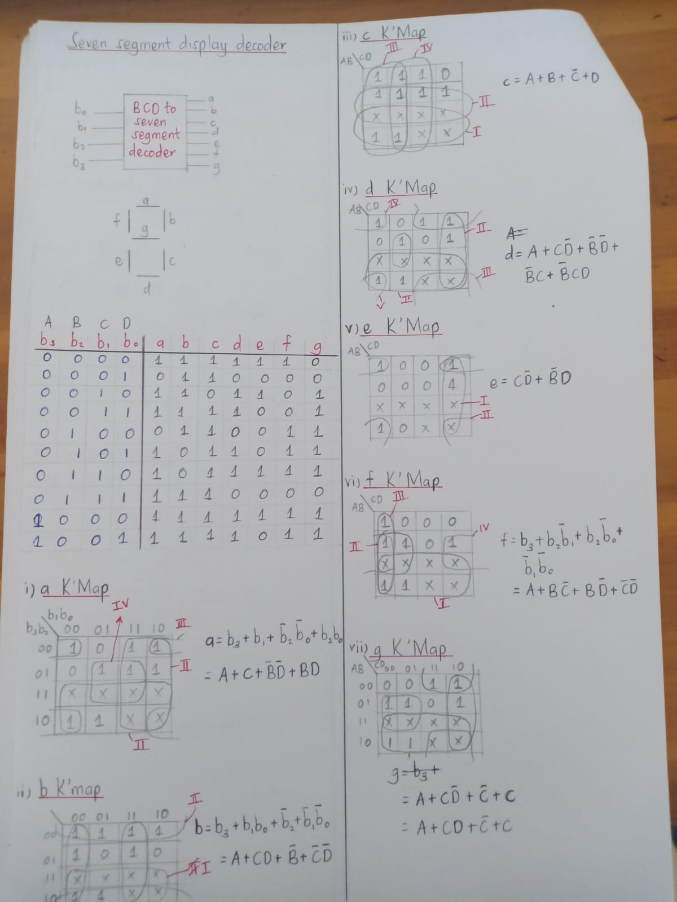
Figure 1

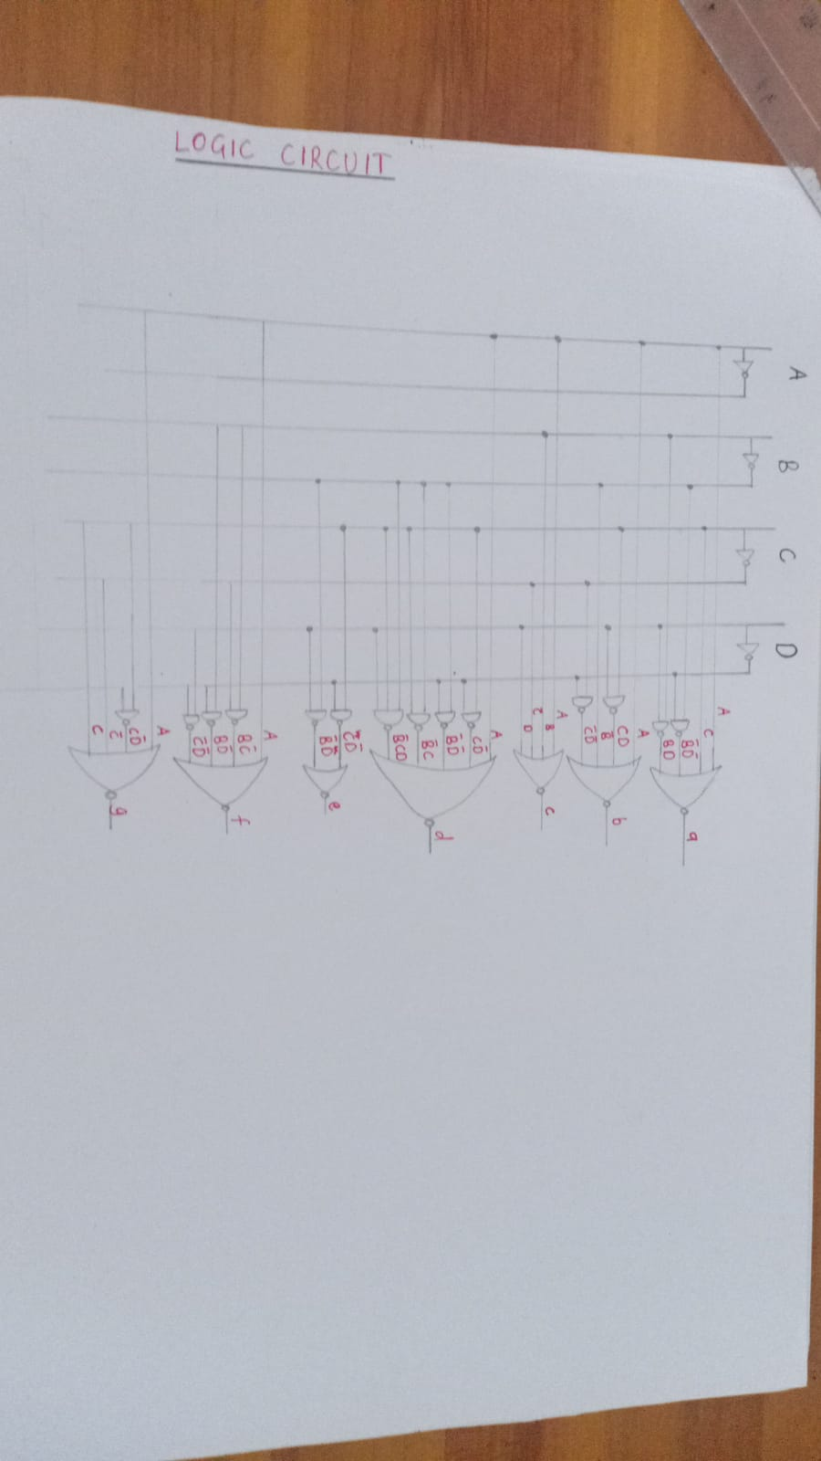
Figure 2
Proteus Simulation
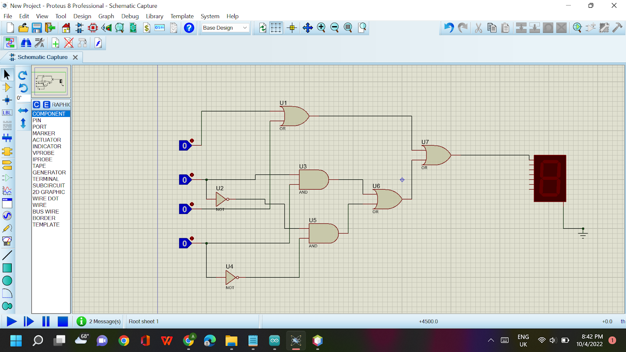
Figure 3

1.4.2:
Use the Truth Table shown Fig. 4.4.2 and a K-map that includes don’t care states to obtain a minimized logic expression to display segment g. Design and draw a schematic of a 16-to-1 logic circuit that will have A, B, C D as inputs to display segment g on a 7-segment display.
Calculations:
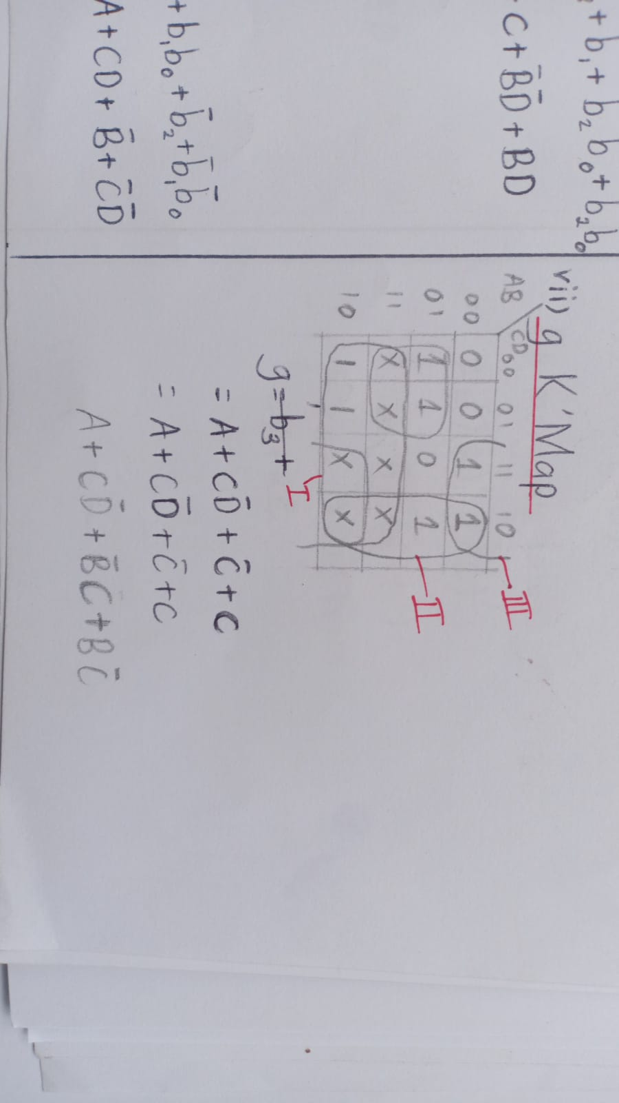
Figure 4
Proteus Schematic:
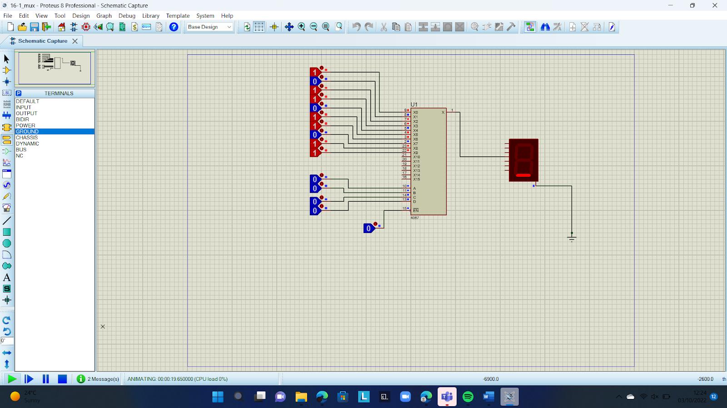
Figure 5

1.4.3:
Use the Truth Table shown Fig. 4.4.2 and a K-map that includes don’t care states to obtain a minimized logic expression to display segment b. Design and draw a schematic of a circuit that will have A, B, C D as inputs to Arduino Uno analogue pins and write a program to display segment b on a 7 segment display using the digital outputs of the Arduino Uno board. Make sure to include input and output buffers in your circuit to protect the Arduino Uno.
K-Map
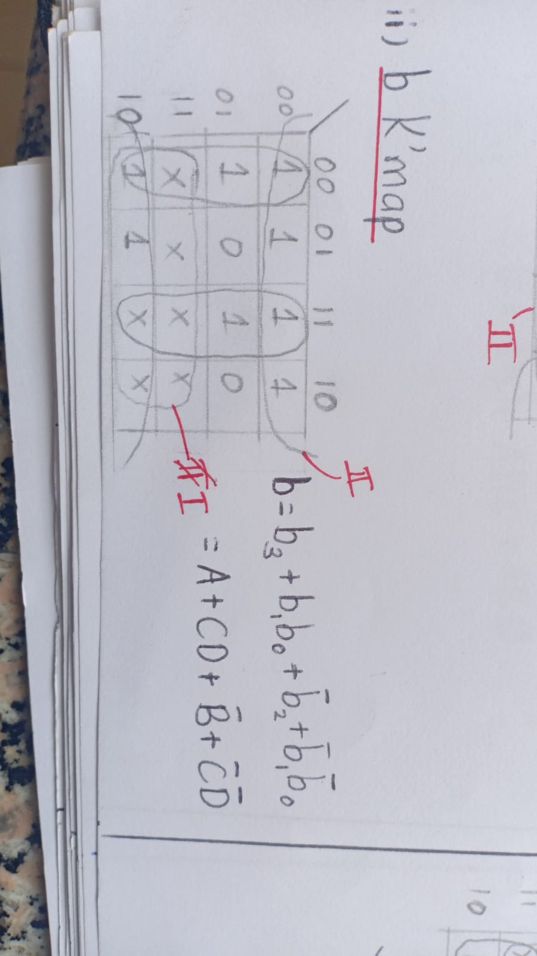
Figure 6
Schematic

Code:
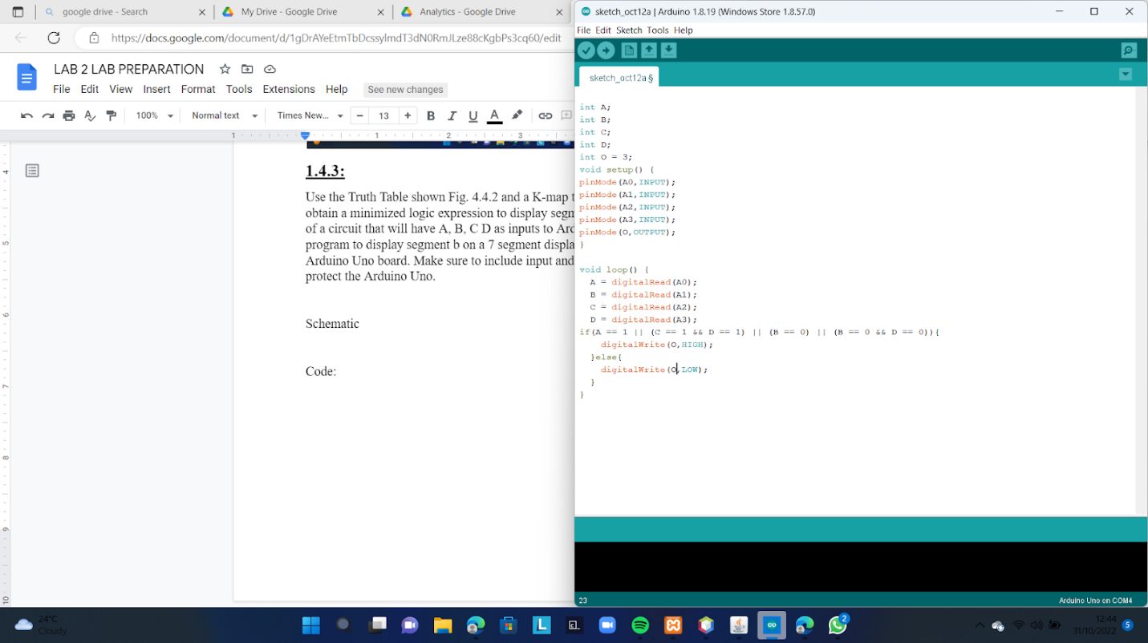
Figure 7

REFERENCES

